**EXPERIMENT-7**

**Aim:** To create a **Docker swarm** cluster.

**Procedure:**

**1)** Using the **docker swarm init** command on a node to initialize it as master node.  
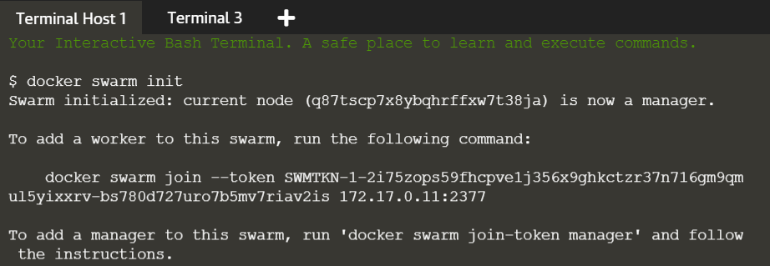

**2)** Copying **docker swarm join --token** command and running it on the another node to join the swarm cluste rand configured as worker node.  
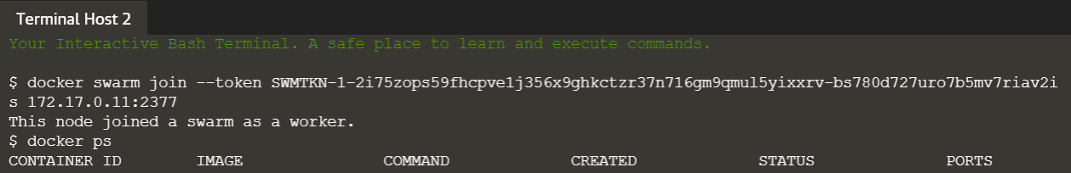

**3)** On the master node run the **docker node ls** command to see all the nodes that have joined the swarm cluster.  
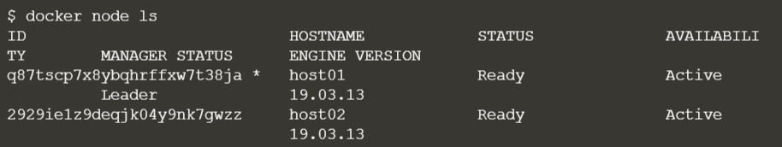

**4)** To create an overlay network via swarm manager node, using the **docker network create -d overlay app1-network** command.  
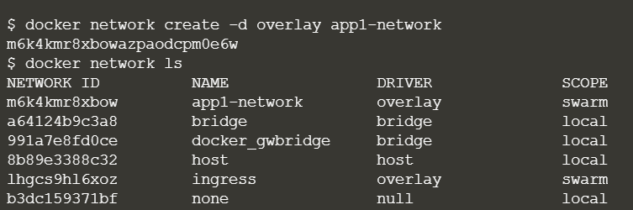

**5)** To create a service, using the **docker service create --network <network-name> -p <port-forwading> --replicas <replicas> --name <service-name> <image-name>.** command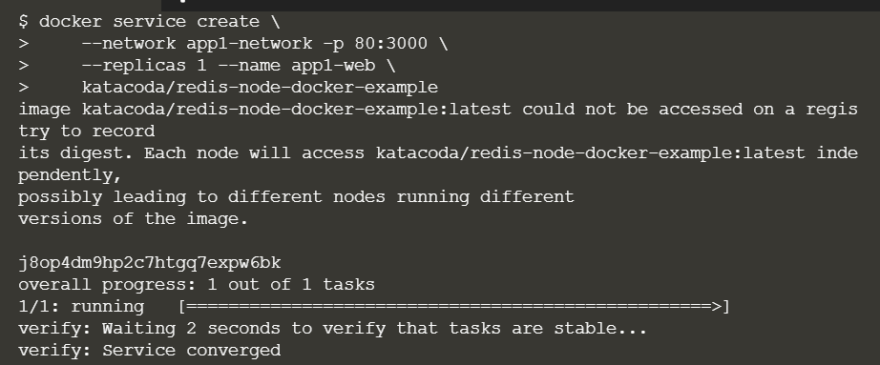

**6)** Using the command docker service ls to check all the services running.  
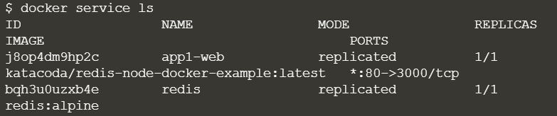

**7)** Using the command **docker service ps <service-name>** to check the state of the service.  
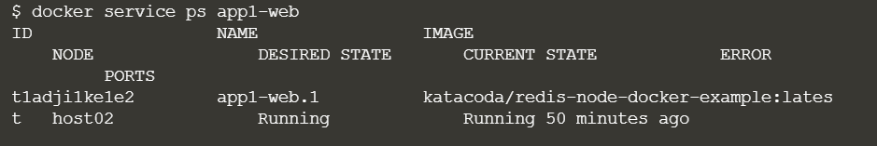

**Submitted by:**

Arjun Rekhi

500068109

R171218028